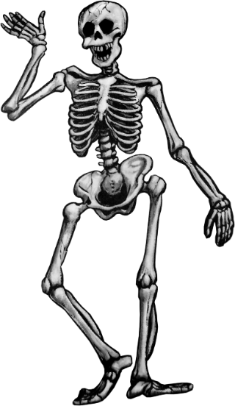
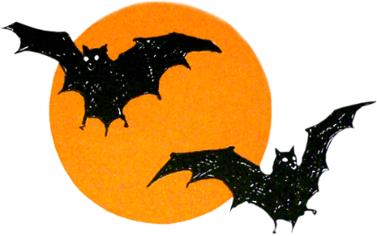

Spanish
Day of the Dead
FREE Video Activities
(Videos from YouTube)
Created by Dana Lovallo
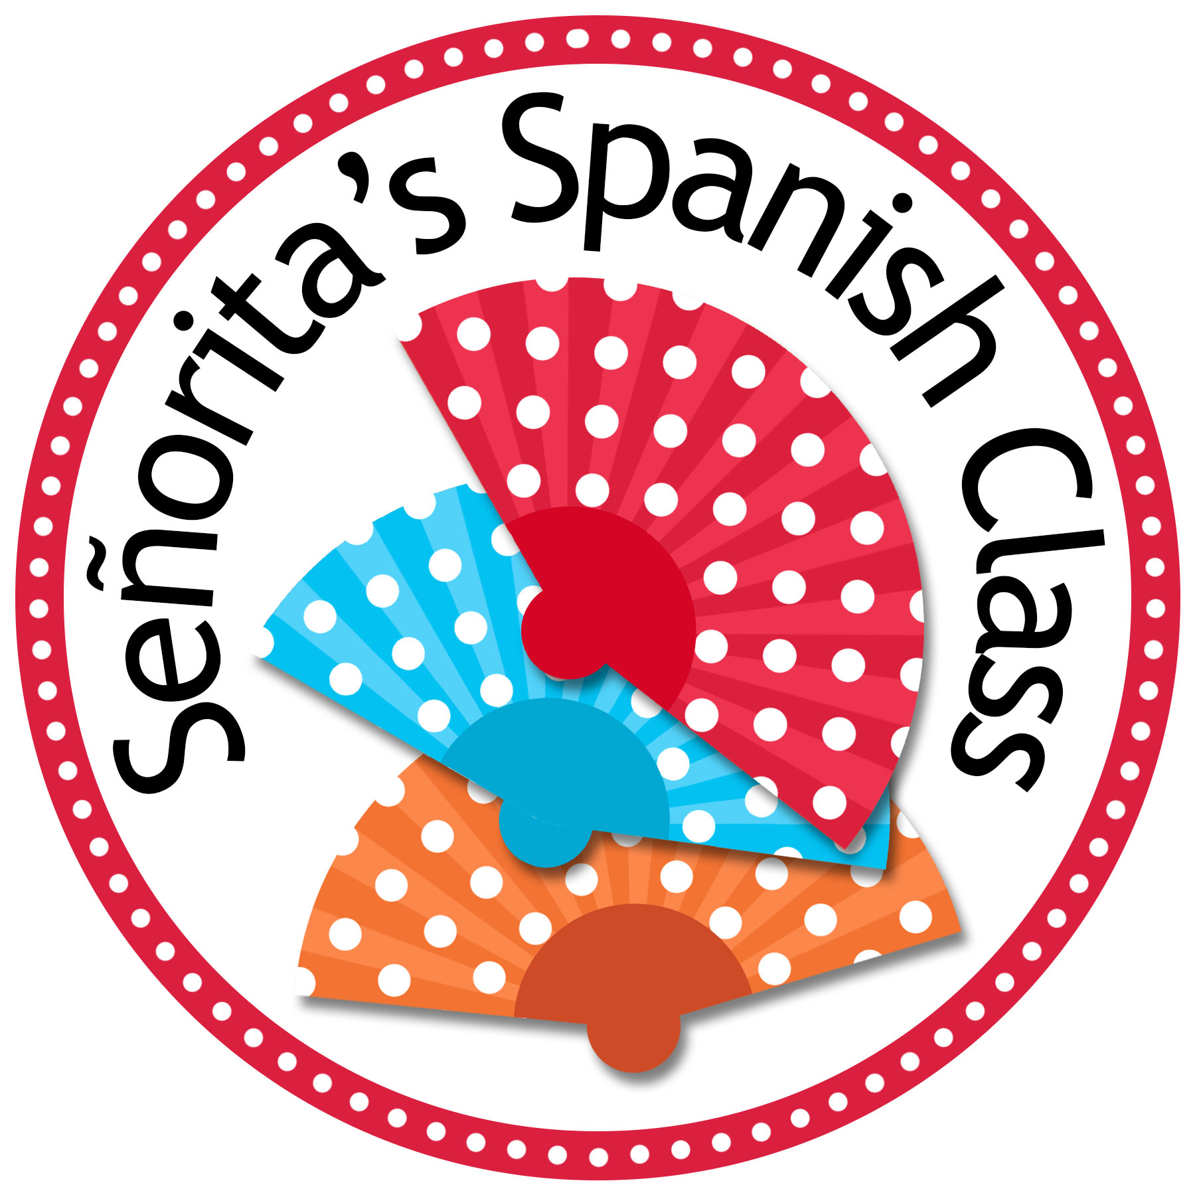
https://www.teacherspayteachers.com/Store/Senoritas-Spanish-Class
© Dana Lovallo @ Señorita’s Spanish Class, 2015

© Dana Lovallo @ Señorita’s Spanish Class, 2015
Terms of Use
Thank you for downloading this product. Please read the terms of use before distributing this assignment:
All rights reserved. Purchase of this item entitles the purchaser the right to reproduce the pages in limited quantities for classroom use only. Duplication for an entire school, an entire school system or commercial purposes is strictly forbidden without written permission from the author.
Copying any part of this product and placing it on the internet in any form (even a personal/classroom website) is strictly forbidden and is a violation of the Digital Millennium Copyright Act (DMCA). These items will be located by Google and traced back to the publishing site. You may post this on a classroom website if your website requires a password for entry.
If you would like to share this resources with another teacher, please purchase an additional license on your “My Purchases” page at any time.
It is my sincere hope that you enjoy this product and find it helpful! If you have any questions regarding this product, please do not hesitate to contact me at dana.c.lovallo@gmail.com
Thank you for your cooperation!
Copyright ©2014-present, Dana Lovallo
All Rights Reserved
Credits:
Instructions for use:
This free product is a collection of links to three short videos on YouTube that focus on the traditions surrounding Day of the Dead in Mexico. The video links are provided at the top of each worksheet. In addition, the three videos and two extra videos can be viewed together in my blog: http://senoritasspanishclass.blogspot.com/
Each of the three videos have 8-10 comprehension questions (written in English) that ask students about the various traditions that are celebrated with Day of the Dead. Students can respond to these questions in English or in Spanish if preferred.
Answer keys are included for each worksheet.
It is suggested that students watch these videos on separate days to accompany a unit or class discussion on Day of the Dead. The videos range from 3-7 minutes long and are a nice way to “hook” students for a lesson on Day of the Dead.
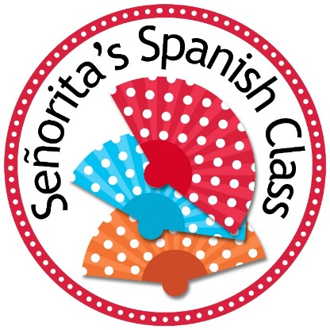
If you have any questions regarding this product, please do not hesitate to contact me.

Dana Lovallo
dana.c.lovallo@gmail.com
Señorita’s Spanish Class

Día de los Muertos - 1
Nombre: __________________________________ Periodo: _____ Fecha: ____________________________

Answer the following questions while watching this video about Day of the Dead celebrations in Mexico: https://www.youtube.com/watch?v=yUIHhSOd1GI (6:55)

- When is Day of the Dead celebrated?
____________________________________________________________________________________________________________
- Which two countries does the video focus on?
____________________________________________________________________________________________________________
- Day of the Dead is a mix of which two cultures and traditions?
____________________________________________________________________________________________________________
- Is it a sad holiday?
____________________________________________________________________________________________________________
- What do people believe happens on Day of the Dead (generally speaking)?
____________________________________________________________________________________________________________
- What is a pretty constant tradition no matter where you are in Mexico?
____________________________________________________________________________________________________________
- What do people do while at the cemetery?
____________________________________________________________________________________________________________
- What items are usually on the altars?
____________________________________________________________________________________________________________
- Why is there water at the altar?
____________________________________________________________________________________________________________
- Skulls are everywhere in Mexico! What types of skulls do they mention in the video?
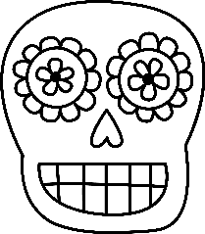
________________________________________________________________________________________________________
Nombre: __________________________________ Periodo: _____ Fecha: ____________________________

Día de los Muertos - 2
Nombre: __________________________________ Periodo: _____ Fecha: ____________________________
Answer the following questions while watching this video about Day of the Dead “ofrendas” created by young students in Minneapolis: https://www.youtube.com/watch?v=j5vs3RcYAyg (3:42)
- Why are the ofrendas created?
____________________________________________________________________________________________________________
- Day of the Dead is a mix of what two things?
____________________________________________________________________________________________________________
- What is one of the goals of the holiday?
____________________________________________________________________________________________________________
- Who do the students’ ofrendas honor?
____________________________________________________________________________________________________________
- What types of things are included on the altars?
____________________________________________________________________________________________________________
- The ofrendas act as what for the students?
____________________________________________________________________________________________________________
- What does the bright color of the flowers help to do?
____________________________________________________________________________________________________________
- What is the goal of the ofrenda?
____________________________________________________________________________________________________________
- Why did the museum choose to focus on “young people’s” ofrendas?
____________________________________________________________________________________________________________

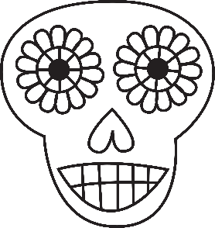

Día de los Muertos - 3
Nombre: __________________________________ Periodo: _____ Fecha: ____________________________
Answer the following questions while watching this animated video about a girl’s fictional experience with Day of the Dead: https://www.youtube.com/watch?v=jCQnUuq-TEE (3:07)
- What is the girl’s attitude of her family member’s death in the first seconds of the video?
____________________________________________________________________________________________________________
- Where does the girl end up?
____________________________________________________________________________________________________________
- What’s the recurring symbol in the video?
____________________________________________________________________________________________________________
- How does the girl act when she’s in the new world at first?
____________________________________________________________________________________________________________
- How do the skeletons act in the new world? Are they happy or scary?
____________________________________________________________________________________________________________
- How does the girl’s attitude change throughout the video?
____________________________________________________________________________________________________________
- Who is the skeleton in the end?
____________________________________________________________________________________________________________
- What does the blue flower symbolize in your opinion?
____________________________________________________________________________________________________________

Thank you for your download!
I hope you enjoy using this product in your classroom. Don’t forget that you can earn TpT credits to use on future products by leaving feedback. Please consider following me for product updates and sales! My new products are 50% off for the first 48 hours. Simply click the green star under my store name at this link:
https://www.teacherspayteachers.com/Store/Senoritas-Spanish-Class

You may also like the following Spanish holiday products:
